**LESSON 1**

REQUIRED POSSIBLE –COMBINATION

ALL **P**OSSIBLE OUTPUTS (taking from left, as well as right hand)—**PERMUTATION**

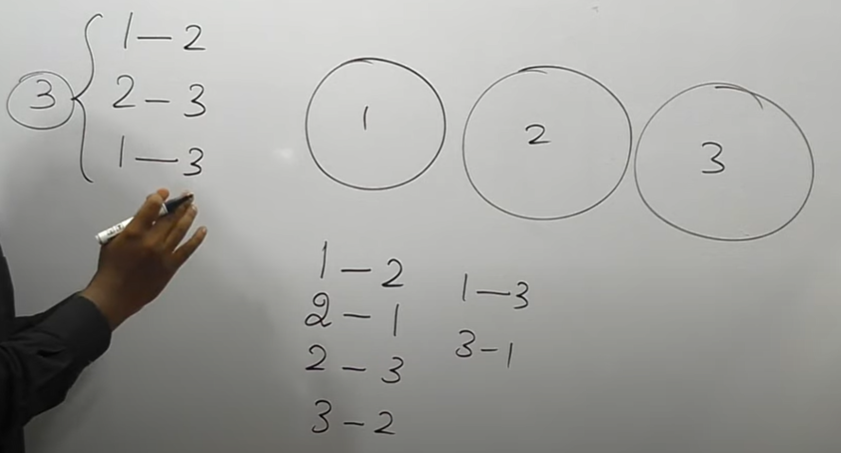

n-total r-selection

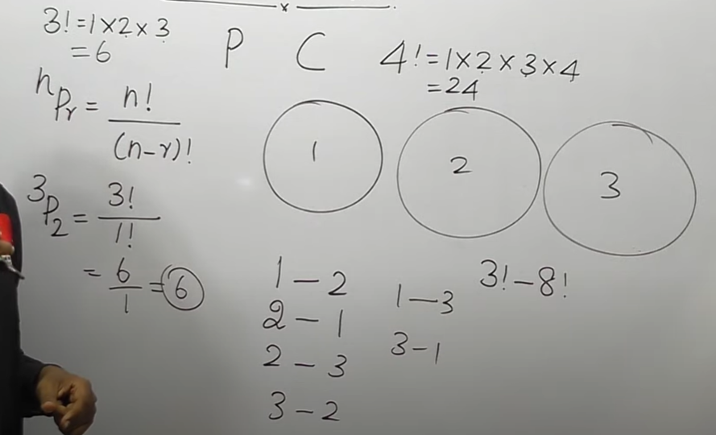

**LESSON 2**

**TYPE 1- NON REPEATED LETTERS LESSON 2**

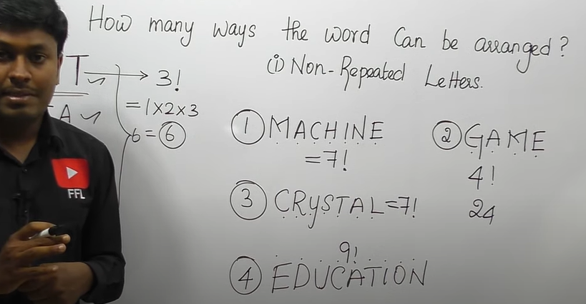

**TYPE 2- REPEATED LETTERS**

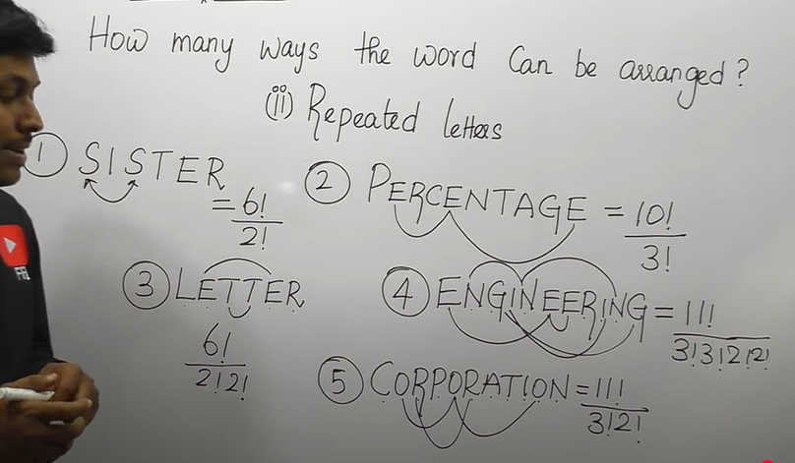

**LESSON 3**

**VOWELS COMES TOGETHER (NON-REPEATED LETTERS)**

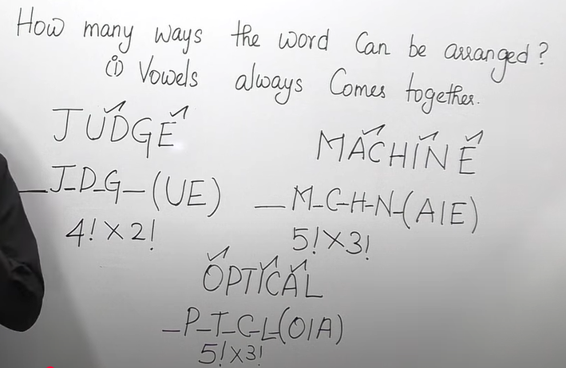

**VOWELS COMES TOGETHER ( REPEATED LETTERS)**

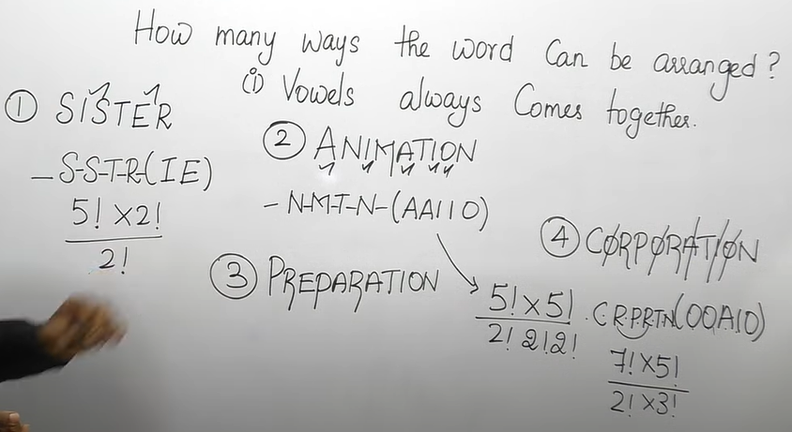

**CONSONANTS COMES TOGETHER ( REPEATED LETTERS)**

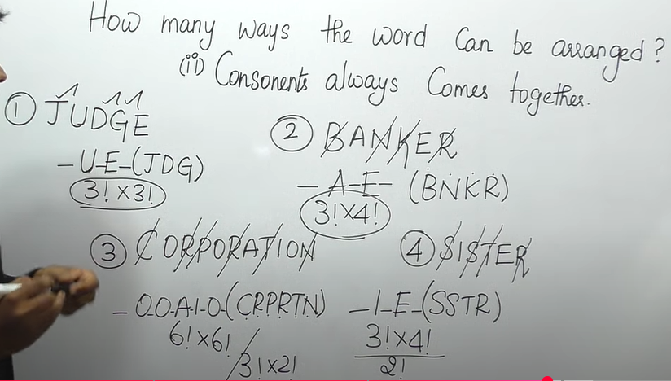

**SOME LETTERS COMES TOGETHER:**

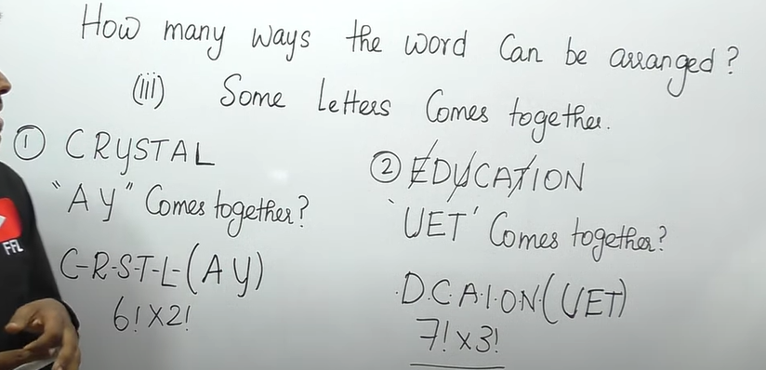

**LESSON 4**

**VOWELS NEVER COMES TOGETHER**

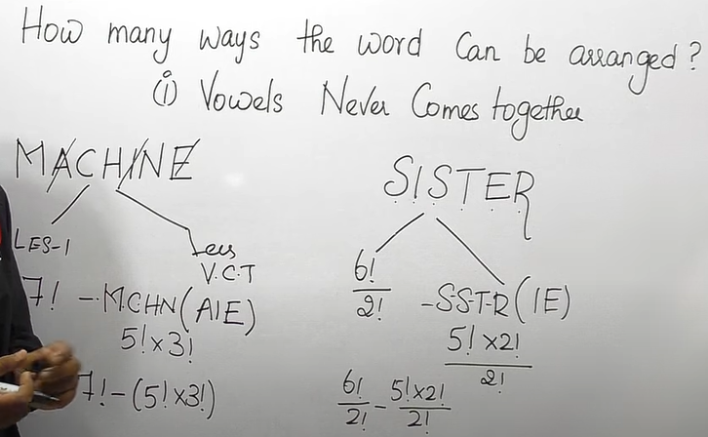

**CONSONANTS NEVER COMES TOGETHER**

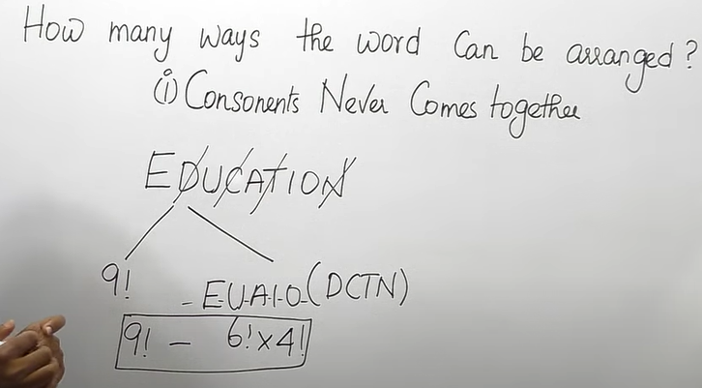

**LESSON 4**

**NO TWO VOWELS / CONSONANTS COMES TOGETHER**

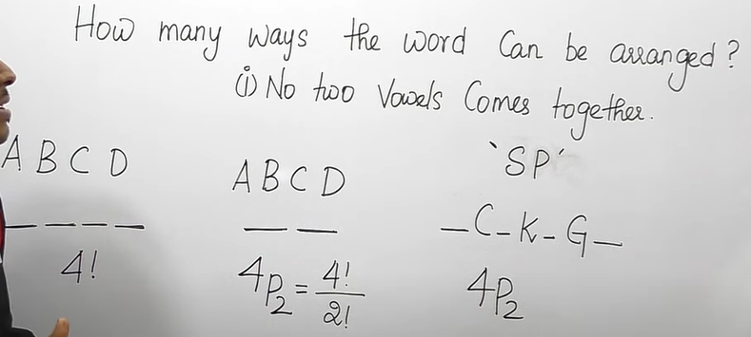

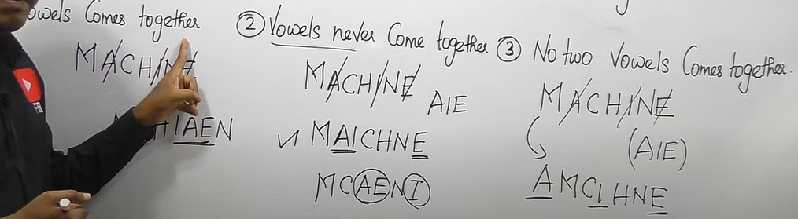

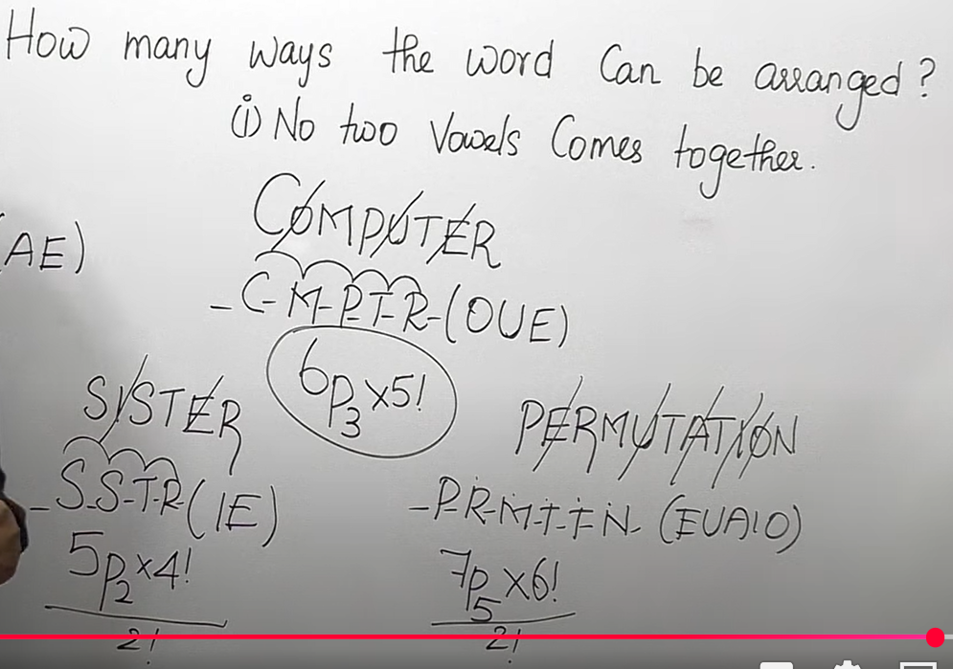

**LESSON 5**

**VOWELS / CONSONANTS COMES IN ODD/ EVEN PLACES**

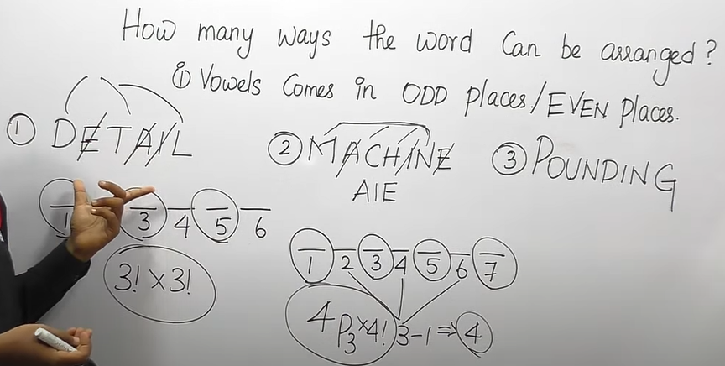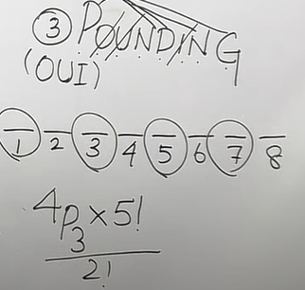

**LESSON 6**

**REPETITION ALLOWED/ NOT ALLOWED**

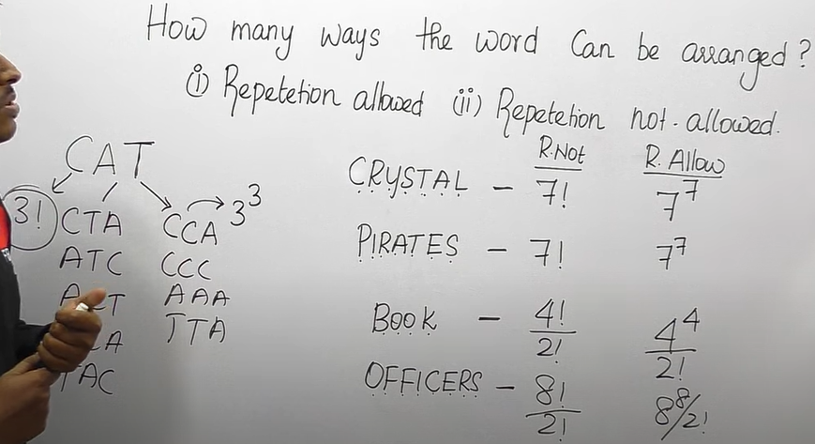

**LESSON 7**

**MISCELLANEAOUS QUESTION**

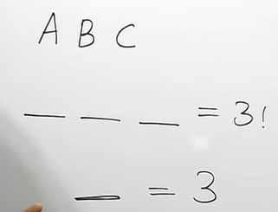

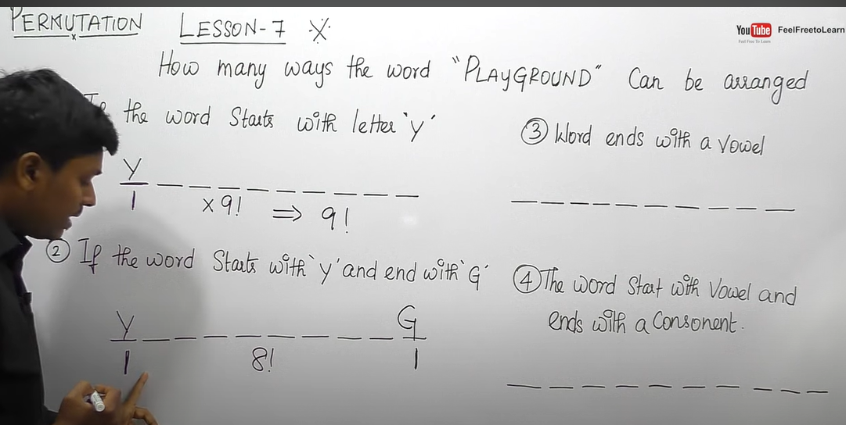

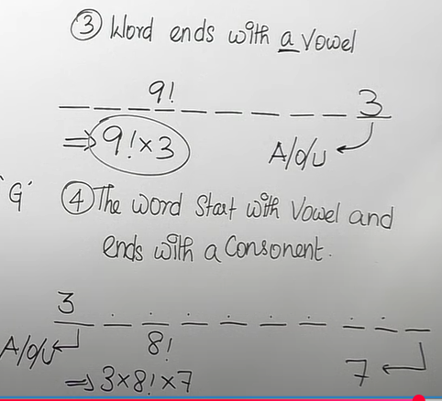

**LESSON 8**

**PROBLEMS BASED ON NUMBERS**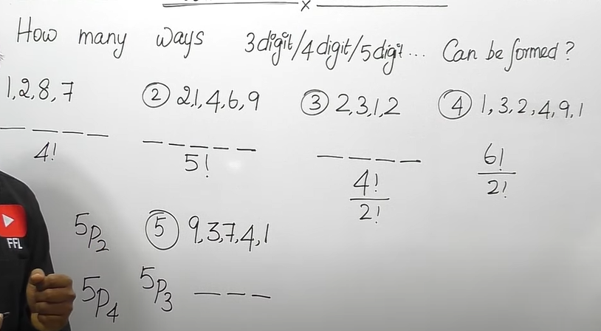

**LESSON 8**

**NON ZERO NUMBERS**

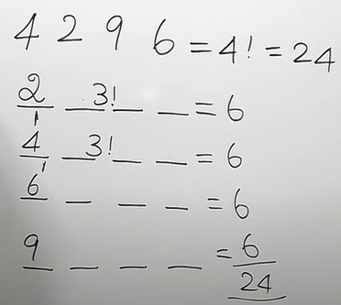

**BASED ON NUMBER ZERO**

